Installation Guide - Step 1 - Install ROS on laptop

We are going to assume you have a laptop with a fresh install of Ubuntu 20.04 and have no previously installed ROS components. After loading 20.04 for the first time, wait for software updater to recognize updates need to be run and then select install
- Install Ubuntu 20 from USB drive
- Make sure you select extra software so wi-fi is enabled
- Change bios to boot from HDD
- After installation, Press RESTART NOW
          - With USB drive still connected; This forced me to do a hard reboot; then I disconnected the USB drive and rebooted - Ubuntu from HDD then fired up
- Connect to wi-fi
- Set screen timeout to never: Settings -> Power -> Power Savings -> Blank Screen -> Never
Update ubuntu with latest updates:
- $ sudo apt update
- $ sudo apt upgrade
Connect to NAS Drive
$ sudo apt install nfs-common
$ sudo mkdir -p /mnt/nasdrive_documents
$ sudo mount [NFS _IP]:/[NFS_export] [Local_mountpoint]
$ sudo mount 192.168.1.40:/volume1/documents /mnt/nasdrive_documents

Once you have mounted the NFS share, you can confirm it using the following command:

$ df –h

to automatically mount at boot time edit the /etc/fstab file using the following command:

$ sudo nano /etc/fstab

the entry would be:

192.168.1.40:/volume1/documents /mnt/nasdrive_documents nfs defaults 0 0

install Brave as the default browser;
• sudo apt install curl
• sudo curl -fsSLo /usr/share/keyrings/brave-browser-archive-keyring.gpg https://brave-browser-apt-release.s3.brave.com/brave-browser-archive-keyring.gpg
• echo "deb [signed-by=/usr/share/keyrings/brave-browser-archive-keyring.gpg arch=amd64] https://brave-browser-apt-release.s3.brave.com/ stable main"|sudo tee /etc/apt/sources.list.d/brave-browser-release.list
• sudo apt update
• sudo apt install brave-browser

Open Brave; set as default; Settings->Sync; Copy sync code (make sure the last word is copied);

Synchronize everything; Launch; Right click and Add to Favorites

Go to github and download these instructions (i.e. Step 1)

Check if you can get to protonvpn.com. If not update resolv.config with opendns entries

Install Chrony as the Network Time Protocol tool ref
- $ sudo apt install chrony
- $ sudo systemctl enable chrony
- $ sudo systemctl start chrony
- $ sudo systemctl status chrony # check status
- Commands for debugging and checking status are:
  - $ chronyc tracking
  - $chronyc sources -v
  - $ sudo chronyc -a makestep # to update the time immediately
To fix a GPG key issue
- $ sudo apt install curl
- $ sudo sh -c 'echo "deb http://packages.ros.org/ros/ubuntu $(lsb_release -sc) main" > /etc/apt/sources.list.d/ros-latest.list'
- $ curl -s https://raw.githubusercontent.com/ros/rosdistro/master/ros.asc | sudo apt-key add -
Update ubuntu with latest updates:
- $ sudo apt update
- $ sudo apt upgrade

I had an issue updating snap….https://askubuntu.com/questions/1411104/unable-to-update-snap-store-cannot-refresh-snap-store-snap-snap-store-ha

$ sudo snap refresh
$ sudo pkill snap-store && sudo snap refresh snap-store

Install VSCode; Open Ubuntu Software, type Visual Studio Code,
Install platformio

VSCode will need access to the serial port to display activity
$ sudo chmod 666 /dev/ttyACM0 (I believe there needs to be a board connected to ACM0 for this to work)

- First install updated python $ sudo apt-get install python3-venv
  - 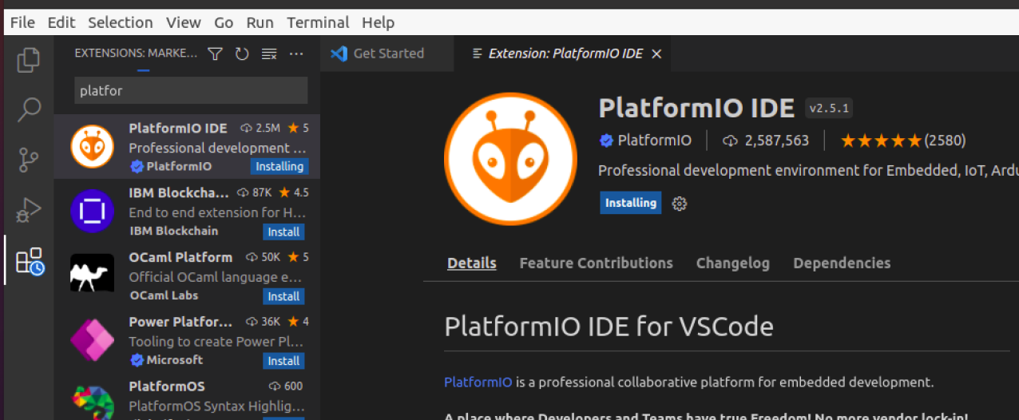
  - https://code.visualstudio.com/docs/?dv=linux64_deb

The port speed I normally use is 115,200
$ stty -F /dev/ttyAMA0 115200

Install VNC Connect which includes Server and Viewer – look for ....Linux-x64...
Download VNC-Server at https://www.realvnc.com/en/connect/download/vnc/linux/
Copy the name with the version so you can update the statement below
$ sudo dpkg -i /home/{user}/Downloads/VNC-Server-{version}-Linux-x64.deb

Install Sublime as an editor
- $ wget -qO - https://download.sublimetext.com/sublimehq-pub.gpg | sudo apt-key add -
- $ sudo apt-get install apt-transport-https
- $ echo "deb https://download.sublimetext.com/ apt/stable/" | sudo tee /etc/apt/sources.list.d/sublime-text.list
- $ sudo apt-get update
- $ sudo apt-get install sublime-text
- Ref: https://www.sublimetext.com/docs/linux_repositories.html

Install ROS using the instructions at http://wiki.ros.org/ROS/Installation
- $ sudo sh -c 'echo "deb http://packages.ros.org/ros/ubuntu $(lsb_release -sc) main" > /etc/apt/sources.list.d/ros-latest.list'
- $ sudo apt install curl # if you haven't already installed curl
- $ curl -s https://raw.githubusercontent.com/ros/rosdistro/master/ros.asc | sudo apt-key add -
- $ sudo apt update
- $ sudo apt install ros-noetic-desktop-full
- $ source /opt/ros/noetic/setup.bash
- $ printenv | grep ROS
You have now installed ROS. If you want to check to see how the variable names are setup you can display them by entering the following command: $ printenv | grep ROS The output will look similar to this:

- tractor@tractor-HP-ProBook-645-G1:~$ printenv | grep ROS
- ROS_VERSION=1
- ROS_PYTHON_VERSION=3
- ROS_PACKAGE_PATH=/opt/ros/noetic/share
- ROSLISP_PACKAGE_DIRECTORIES=
- ROS_ETC_DIR=/opt/ros/noetic/etc/ros
- ROS_MASTER_URI=http://localhost:11311
- ROS_ROOT=/opt/ros/noetic/share/ros
- ROS_DISTRO=noetic
- tractor@tractor-HP-ProBook-645-G1:~$

Create a ROS Workspace Using Catkin:
$ mkdir -p ~/catkin_ws/src
$ cd ~/catkin_ws/
$ catkin_make

If all goes well you should see this:
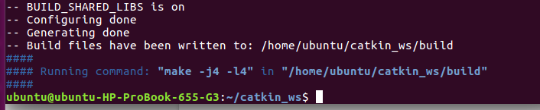

$ source devel/setup.bash
$ echo $ROS_PACKAGE_PATH #This command is to check To make sure your workspace is properly overlayed by the setup script. The output should look like:
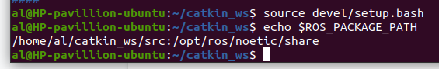

Enter $ roscd # It should to take you to: ubuntu@ubuntu-HP-ProBook-655-G3:~/catkin_ws/devel$

To avoid having to run $ source ~/catkin_ws/devel/setup.bash whenever you open a new terminal you have to add the aforementioned line at the very end of your ~/.bashrc file.

Use the nano editor to change .bashrc. Enter $ nano ~/.bashrc

Use the down arrow and go to the bottom of the file. It should look like this:
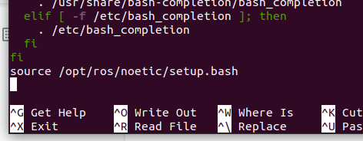
Add

- >source /opt/ros/noetic/setup.bash
- >source /home/{user}/catkin_ws/devel/setup.bash

Then Ctrl+o; enter; to write the updated file; Ctrl+x to exit; Ctrl+Alt+T to open a new window. In that new window enter $ roscd; The results should be:
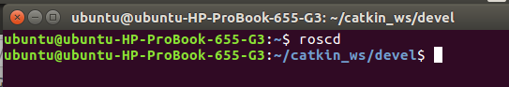
You can close both windows. You now have ROS installed with the catkin environment setup.

ROS Dependancies
- $ sudo apt install python3-rosdep python3-rosinstall python3-rosinstall-generator python3-wstool build-essential
- $ sudo apt install python3-rosdep
- $ sudo rosdep init
- $ rosdep update

- Update wi-fi power saver feature: (I had to do this to improve wi-fi) Run $ sudo nano /etc/NetworkManager/conf.d/default-wifi-powersave-on.conf; Change: wifi.powersave = 3 To: wifi.powersave = 2; Save the file, which should require root password, close the editor and connect to your wi-fi, then reboot.
- Use Ubuntu Software Installed to install Slack
- Arduino - don’t install from Ubuntu library if you are going to use Teensy boards - see PCJR site for instructions

Update ubuntu with latest updates:
- $ sudo apt update
- $ sudo apt upgrade

Install Terminator for terminal windows
$ sudo apt install terminator

Install xdotool to support tkinter – if you will use a gui to start routines
$ sudo apt-get install xdotool

- Save installation steps $ history > historyrosinstall20221206.txt # to show what actual commands you entered

Optional:
Install Chrome.
- Go to https://www.google.com/intl/en-US/chrome/browser/
- Download and open with software install; Ubuntu software should load automatically in about 60 seconds. Then click Install.

- Install video webcam software - $ sudo apt-get install cheese
- Install Zoom for web conferencing

MAKE A DISK IMAGE OF THE LAPTOP AT THIS POINT
- Get Clonezilla Live CD
- Boot Laptop to Live CD
- Copy HDD to Portable USB HDD
- https://clonezilla.org/fine-print-live-doc.php?path=./clonezilla-live/doc/01_Save_disk_image/02-booting.doc#02-booting.doc
- https://clonezilla.org/clonezilla-live.php

- Install Plotjuggler; $ sudo apt install ros-noetic-plotjuggler-roskinetic
- Install FileZilla
$ sudo add-apt-repository ppa:n-muench/programs-ppa
$ sudo apt-get update
$ sudo apt-get install filezilla
- Install Jupyter for notebooks
  - First install the latest PIP:
    - sudo su root
    - apt-get purge -y python-pip
    - wget https://bootstrap.pypa.io/get-pip.py
    - python ./get-pip.py {failed}
    - apt-get install python-pip
    - Exit
  - (https://www.digitalocean.com/community/tutorials/how-to-set-up-a-jupyter-notebook-to-run-ipython-on-ubuntu-16-04)
  - $ sudo apt-get update
  - $ sudo apt-get -y install python2.7 python-pip python-dev
  - $ sudo apt-get -y install ipython ipython-notebook
  - $ sudo -H pip install jupyter
  - Alternate:
    - sudo apt install python3-pip
  - $ jupyter notebook # to open Jupyter
- Tkinter for ROS GUI (version for Python 3)
  - $ sudo apt-get install python3-tk
  - $ sudo apt-get install xdotool
- https://tuxboot.org/download/ in order to test clonezilla
- Setup Hosts file
  - $ sudo nano /etc/hosts
  - 192.168.10.149 tractor_aj
  - > ctrl o, enter; ctrl x
Setup for Tractor / Controller configuration
- Enter $ nano ~/.bashrc
source /home/al/catkin_ws/devel/setup.bash
export ROS_PARALLEL_JOBS=-j2 # Limit the number of compile threads due to memory limits
export ROS_HOSTNAME=controller_aj
# export ROS_MASTER_URI=http://controller_aj:11311
export ROS_MASTER_URI=http://tractor_aj:11311
# export ROS_MASTER_URI=http://localhost:11311
- It should now look like this: {or replace “al” with your userid, “tractor” and “aj” with your preferred identifiers}
- 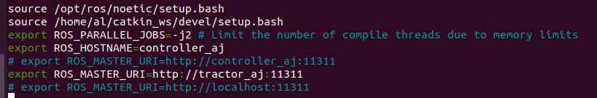
- Then Ctrl+o; enter; to write the updated file; Ctrl+x to exit

